Great Rhombidodecacron

Introduction
# Source: AI Source: Provided by: [Data Path: Persons Table -> ID Column: 1, Name_En Column: Motasem Essam] -> From: [ChatGPT] on [7/25/2026]
The Great Rhombidodecacron, also known as the Great Dipteral Ditriacontahedron, is a non-convex polyhedron in geometry. It is the dual of the Great Rhombidodecahedron.
It is an unusual geometric solid because its faces are intersecting, bow-tie-shaped quadrilaterals called antiparallelograms.
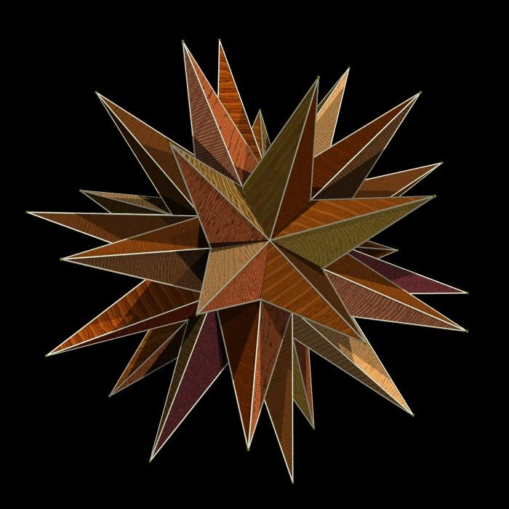

Main Properties
# Source: AI Source: Provided by: [Data Path: Persons Table -> ID Column: 1, Name_En Column: Motasem Essam] -> From: [ChatGPT] on [7/25/2026]
- Type: Non-convex isohedral polyhedron
- Faces: 60 antiparallelograms
- Edges: 120
- Vertices: 42
- Symmetry: Full icosahedral symmetry ($I_{h}$)
- Dual solid: Great Rhombidodecahedron
- Dihedral angle: Approximately ${91.55}^{°}$

Faces
# Source: AI Source: Provided by: [Data Path: Persons Table -> ID Column: 1, Name_En Column: Motasem Essam] -> From: [ChatGPT] on [7/25/2026]
The Great Rhombidodecacron has 60 identical antiparallelogram faces.
An antiparallelogram is a crossed quadrilateral with two pairs of equal-length sides. Its shape resembles a bow tie.
Each face has:
- Two short edges.
- Two long edges.
- Two smaller angles of approximately ${18.70}^{°}$.
- Two larger angles of approximately ${110.21}^{°}$.

Vertices and Edges
# Source: AI Source: Provided by: [Data Path: Persons Table -> ID Column: 1, Name_En Column: Motasem Essam] -> From: [ChatGPT] on [7/25/2026]
The solid contains 42 vertices and 120 edges.
The edges are divided into:
- 60 short edges.
- 60 long edges.
The ratio of the long edge to the short edge is the golden ratio:
$$φ=\frac{1+\sqrt{5}}{2}≈1.618$$

Dual Polyhedron
# Source: AI Source: Provided by: [Data Path: Persons Table -> ID Column: 1, Name_En Column: Motasem Essam] -> From: [ChatGPT] on [7/25/2026]
The dual of the Great Rhombidodecacron is the Great Rhombidodecahedron.
In dual polyhedra:
- Each face of one polyhedron corresponds to a vertex of the other.
- Each vertex corresponds to a face.
- Edges correspond to edges.
The Great Rhombidodecahedron has 42 faces, 120 edges, and 60 vertices. Therefore, its dual has 42 vertices, 120 edges, and 60 faces.

Euler's Formula
# Source: AI Source: Provided by: [Data Path: Persons Table -> ID Column: 1, Name_En Column: Motasem Essam] -> From: [ChatGPT] on [7/25/2026]
For convex polyhedra, Euler's formula is:
$$V−E+F=2$$
For the Great Rhombidodecacron:
$$V=42, E=120, F=60$$
$$42−120+60=−18$$
Its Euler characteristic is $−18$, rather than 2, because it is a self-intersecting, non-convex polyhedral structure.

Construction
# Source: AI Source: Provided by: [Data Path: Persons Table -> ID Column: 1, Name_En Column: Motasem Essam] -> From: [ChatGPT] on [7/25/2026]
A conceptual construction can be described as follows:
- Begin with the Great Rhombidodecahedron.
- Identify its 60 vertices.
- Use each vertex to define a corresponding face of the dual.
- Connect the corresponding points to form 60 antiparallelogram faces.
- Arrange the faces according to the solid's icosahedral symmetry.

Classification
# Source: AI Source: Provided by: [Data Path: Persons Table -> ID Column: 1, Name_En Column: Motasem Essam] -> From: [ChatGPT] on [7/25/2026]
GEOMETRIC CLASSIFICATION
Polyhedra
<icon name="arrow-down" color="secondary" size="lg"/>
Non-convex polyhedra
<icon name="arrow-down" color="secondary" size="lg"/>
Dual polyhedra
<icon name="arrow-down" color="secondary" size="lg"/>
Great Rhombidodecacron

Important Points
# Source: AI Source: Provided by: [Data Path: Persons Table -> ID Column: 1, Name_En Column: Motasem Essam] -> From: [ChatGPT] on [7/25/2026]
- It has 60 antiparallelogram faces.
- It contains 120 edges and 42 vertices.
- It is a non-convex polyhedron.
- It has full icosahedral symmetry.
- Its dual is the Great Rhombidodecahedron.
- Its edge proportions are related to the golden ratio.

Conclusion
# Source: AI Source: Provided by: [Data Path: Persons Table -> ID Column: 1, Name_En Column: Motasem Essam] -> From: [ChatGPT] on [7/25/2026]
The Great Rhombidodecacron is an interesting non-convex polyhedron with 60 bow-tie-shaped faces. Its unusual intersecting structure, icosahedral symmetry, and relationship with the Great Rhombidodecahedron make it an important example in the study of dual polyhedra and advanced geometry.

